**App.js**

import logo from './logo.svg';

import './App.css';

import Home from './Home';

function App() {

  return (

    <div className="App">

      <Home />

    </div>

  );

}

export default App;

**Home.jsx:**

import React, { useState } from "react";

import CurrencyConvertor from "./components/CurrencyConvertor";

const Home = () => {

  const [count, setCount] = useState(0);

  const handleIncrement = (*e*) => {

    setCount(count + 1);

    alert("Hello Member!!");

  };

  const handleDecrement = (*e*) => {

    setCount(count - 1);

  };

  const handleWelcome = (*e*) => {

    alert("Say Welcome");

  };

  const handleClick = (*e*) => {

    alert("I was clicked");

  };

  return (

    <div>

      <p>{count}</p>

      <button onClick={handleIncrement}>Increment</button>

      <br />

      <button onClick={handleDecrement}>Decrement</button>

      <br />

      <button onClick={handleWelcome}>Say Welcome</button>

      <br />

      <button onClick={handleClick}>Click On me</button>

      <CurrencyConvertor />

    </div>

  );

};

export default Home;

**CurrencyConverter.jsx**

import React, { useRef } from "react";

const CurrencyConvertor = () => {

  const amountRef = useRef(null);

  const handleSubmit = (*e*) => {

    e.preventDefault();

    alert("Converting to Indian Rupee is " + amountRef.current?.value * 100);

  };

  return (

    <div>

      <h1 style={{ color: "green", fontWeight: "bold" }}>

        Currency Converter !!

      </h1>

      <form onSubmit={handleSubmit}>

        <label htmlFor="amount"> Amount: </label>

        <input ref={amountRef} type="text" name="amount" id="amount" />

        <br />

        <label htmlFor="currency"> Currency: </label>

        <input type="text" name="currency" />

        <br />

        <input type="submit" value="submit" />

      </form>

    </div>

  );

};

export default CurrencyConvertor;

**OUTPUT:**

**Increment button**

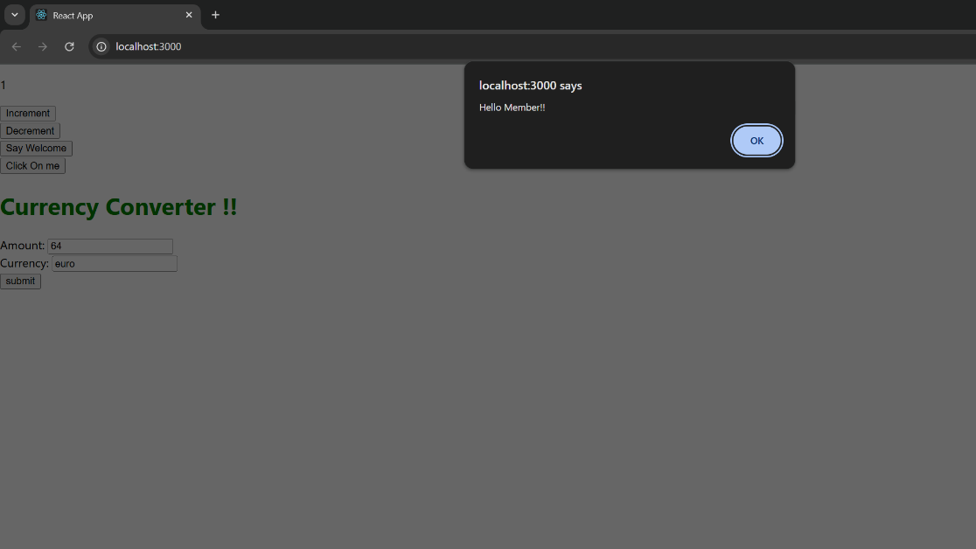

**Say welcome button**

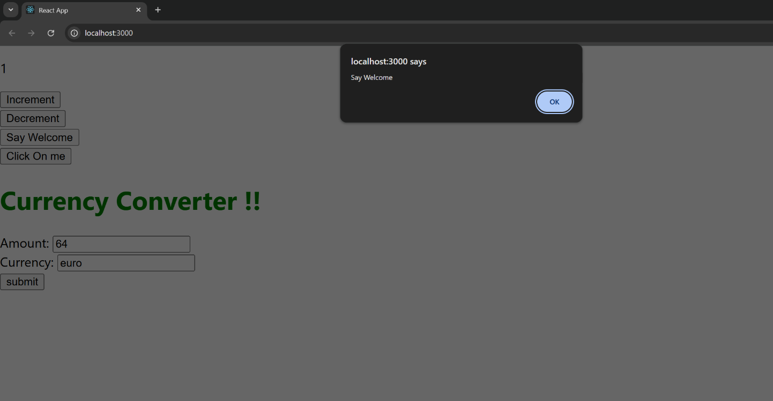

**Click on me button**

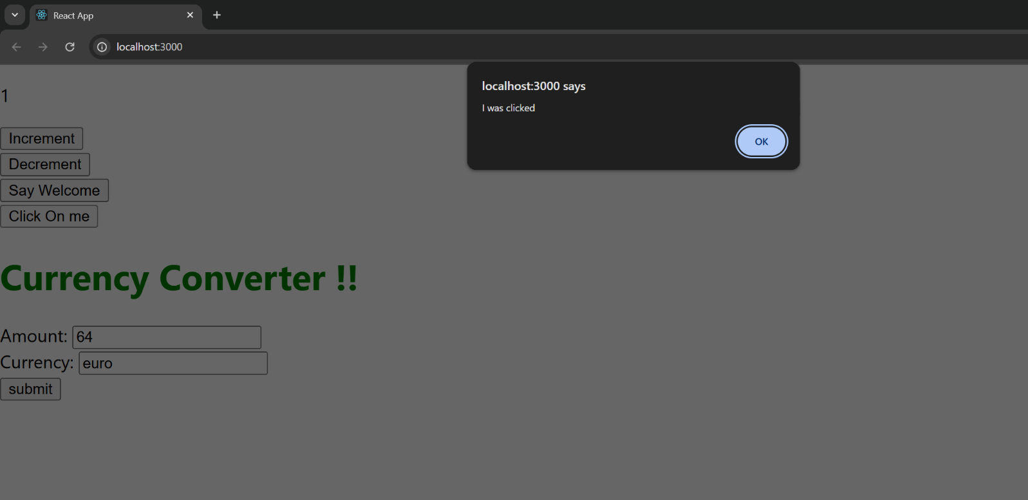

**Currency Converter**

